WIREFRAME
index.html

Get Tickets
Explore Events

NEW DROP: NEXUS NOISE WEEKENDER · TICKETS LIVE · VENUE MAP UPDATED · POP-UP MERCH LAB ·
Party Mode: OFF
Home Events Tickets Check-In Venue Contact Admin
Nexus Events

Event.html
Party Mode: OFF
Nexus Events
Home Events Tickets Check-In Venue Contact Admin

ccc

Check-In.html
Party Mode: OFF
Home Events Tickets Check-In Venue Contact Admin
Nexus Events

Contact.html
Nexus Events
Party Mode: OFF
Home Events Tickets Check-In Venue Contact Admin

admin.html
Home Events Tickets Check-In Venue Contact Admin
Nexus Events
Party Mode: OFF

Venue.html
Nexus Events
Party Mode: OFF
Home Events Tickets Check-In Venue Contact Admin

Tickets.html
Nexus Events
Party Mode: OFF
Home Events Tickets Check-In Venue Contact Admin

SITEMAP
Nexus Event

Contact
Venue
Admin
Check-In
Tickets
Events
Home

Contact the crew
THE VENUE
QR CODE
Tickets & Access
Event Calendar
Log In
Admin Login
STUDIO HOURS
AMENITIES
TRANSFER TICKETS
Quick Ticket Builder
live
Register
All
TONIGHT’S FLOW
EVENTS PERKS
FAQ
Market
Meetup

Workshop

SS/OUTPUT
Home area
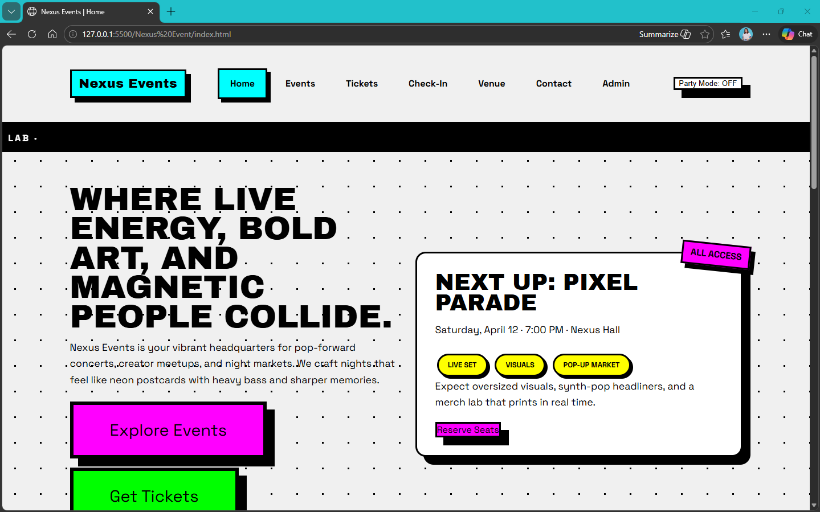
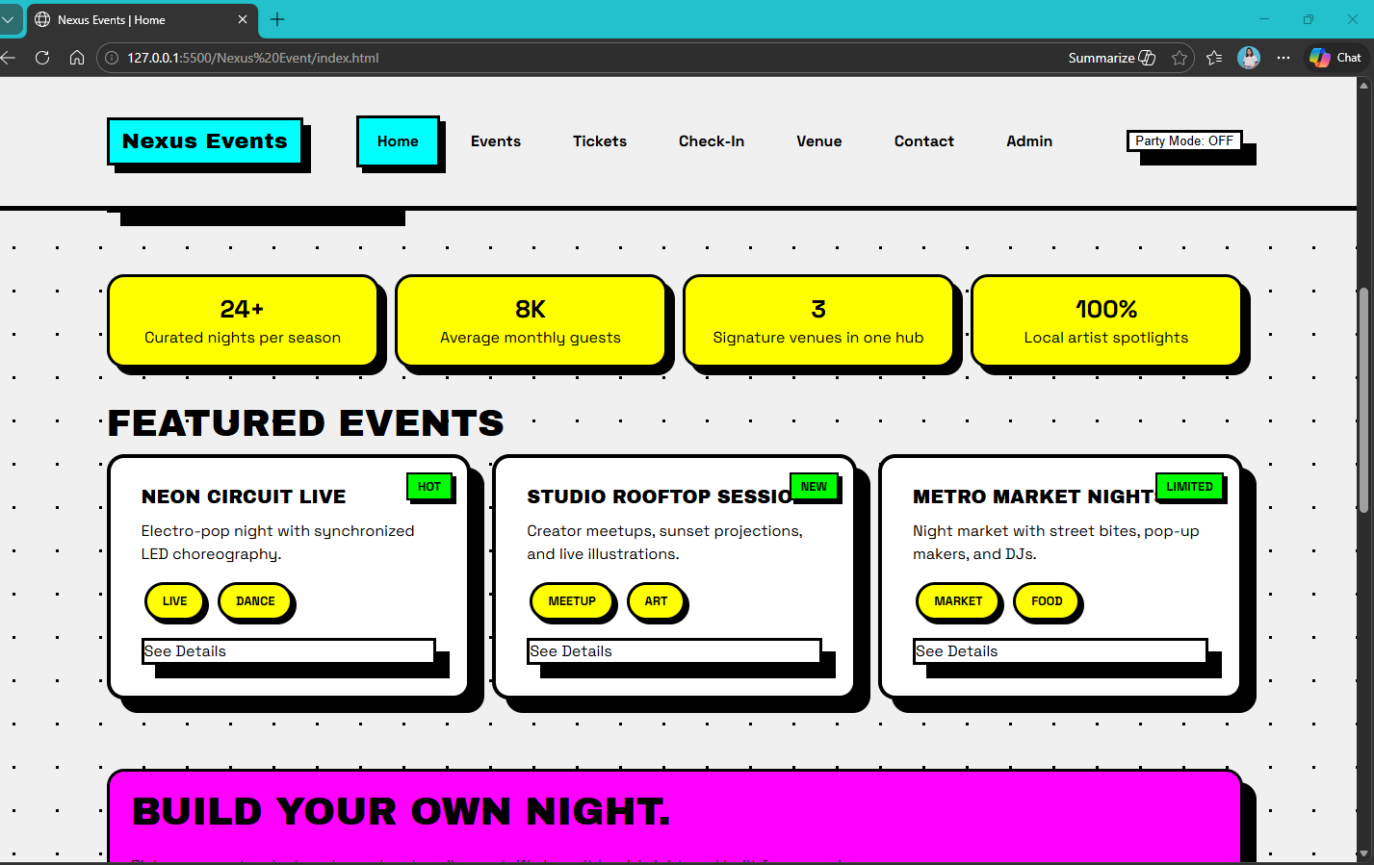
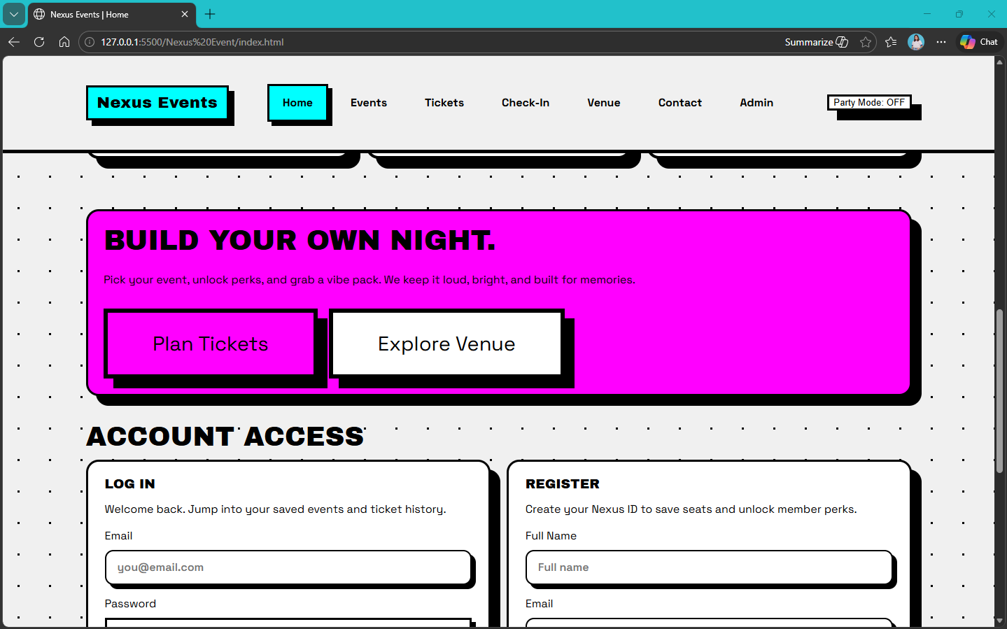

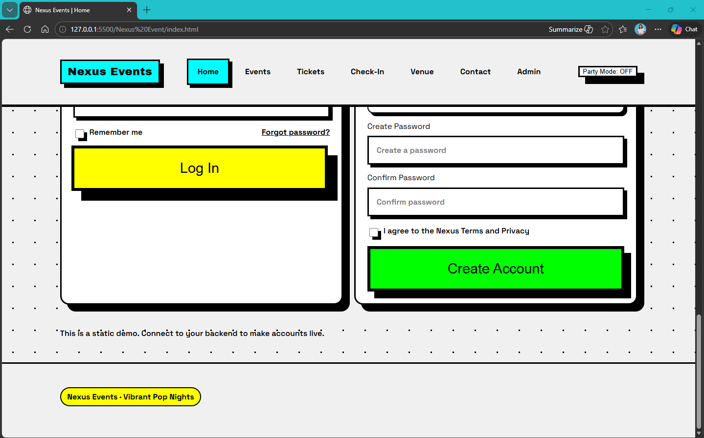

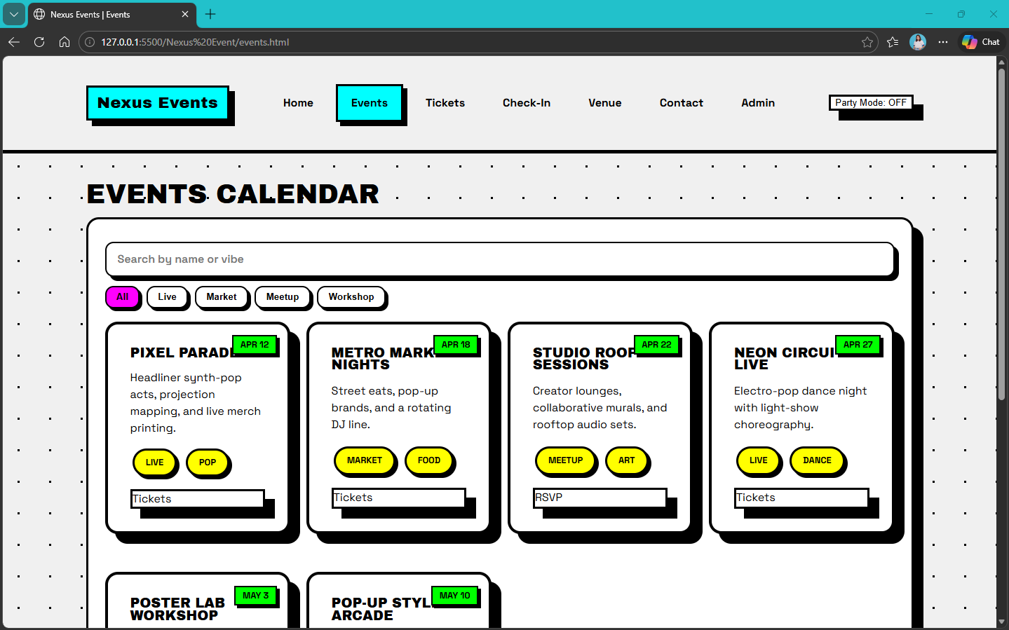
Event Area

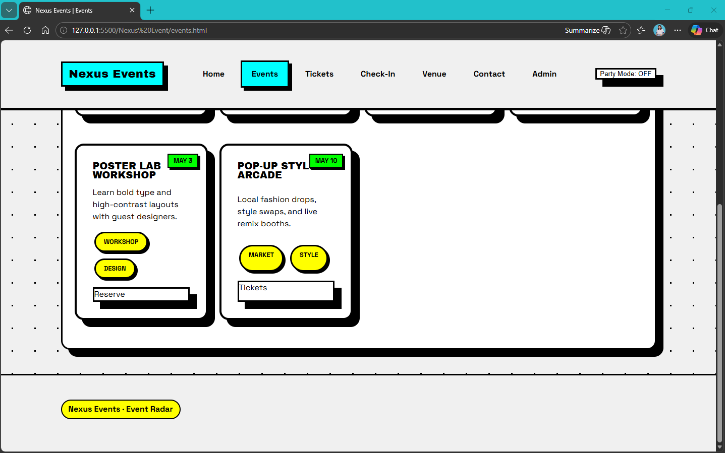

Ticket area
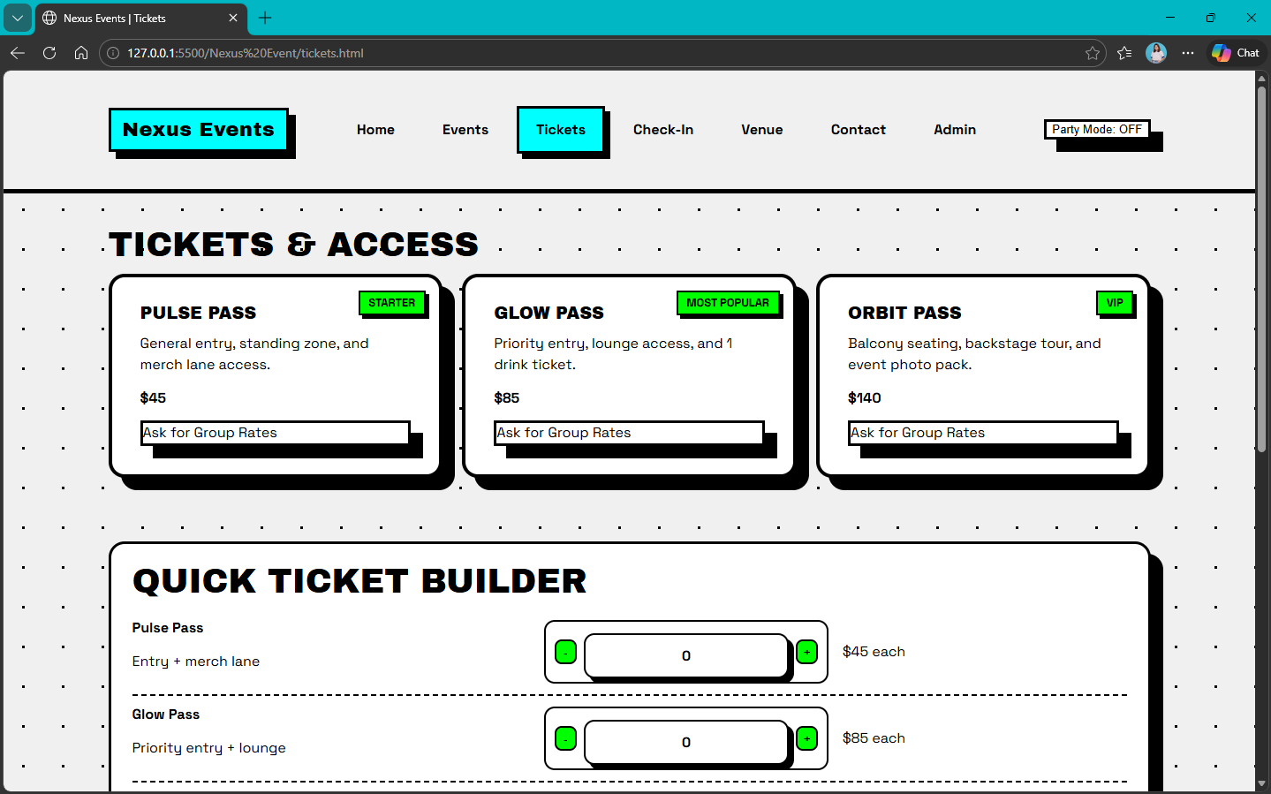
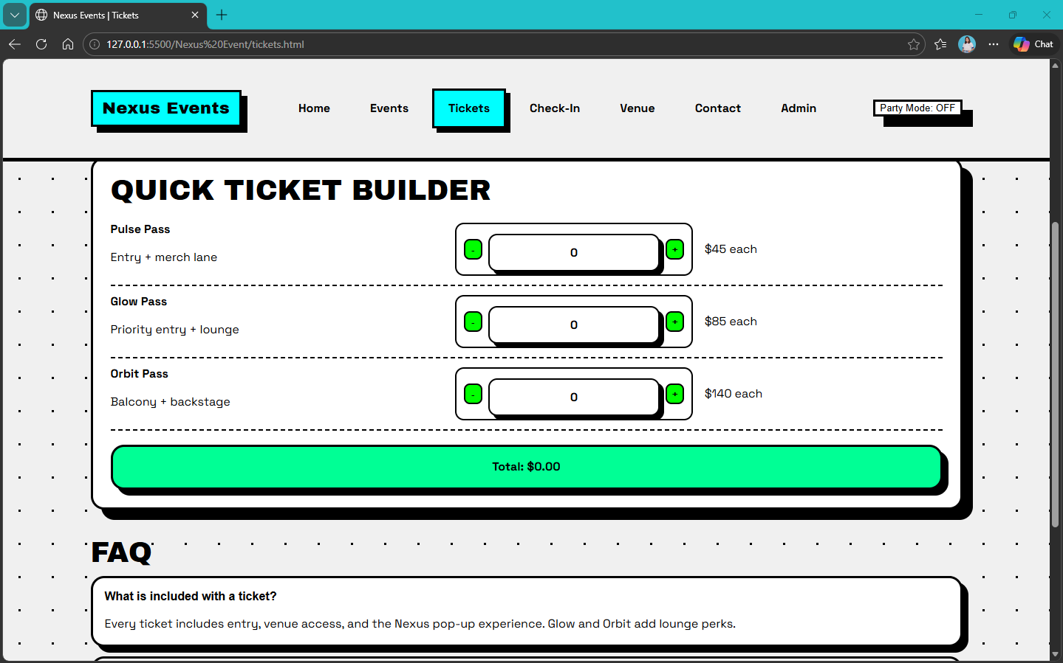

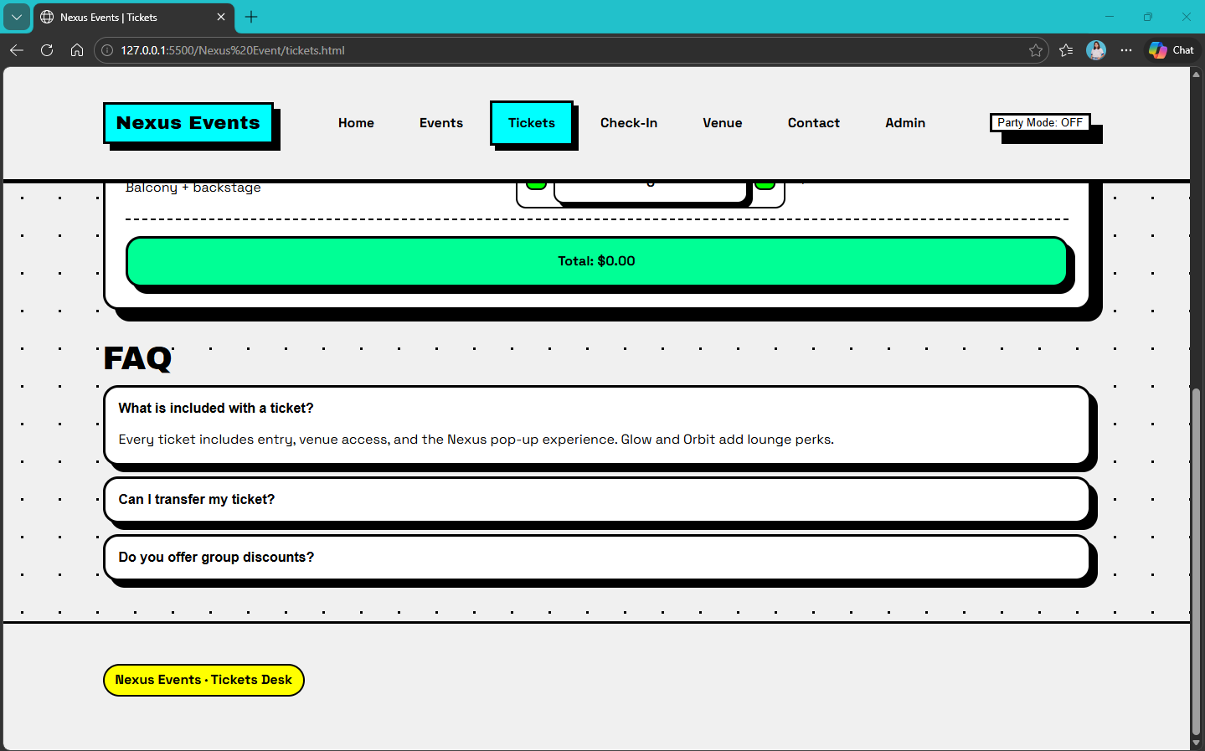

Check-In Area
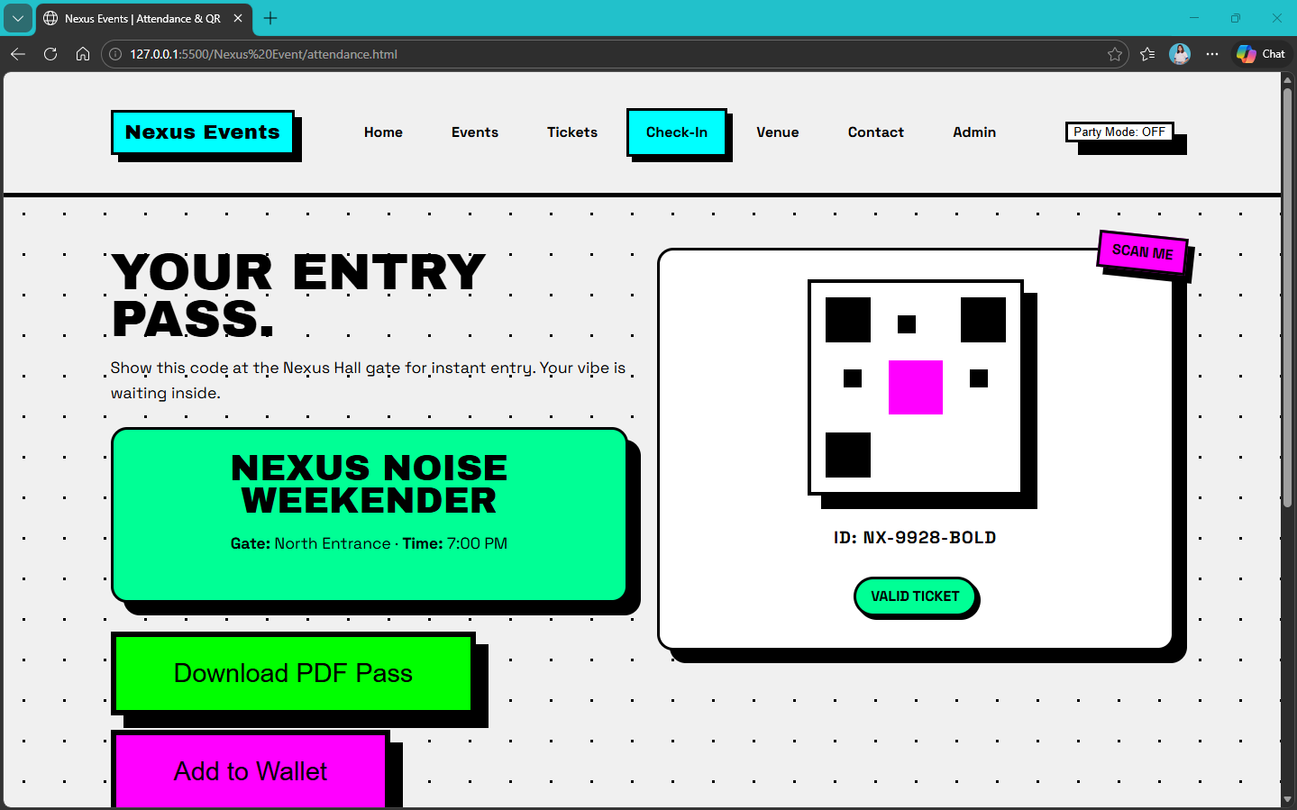
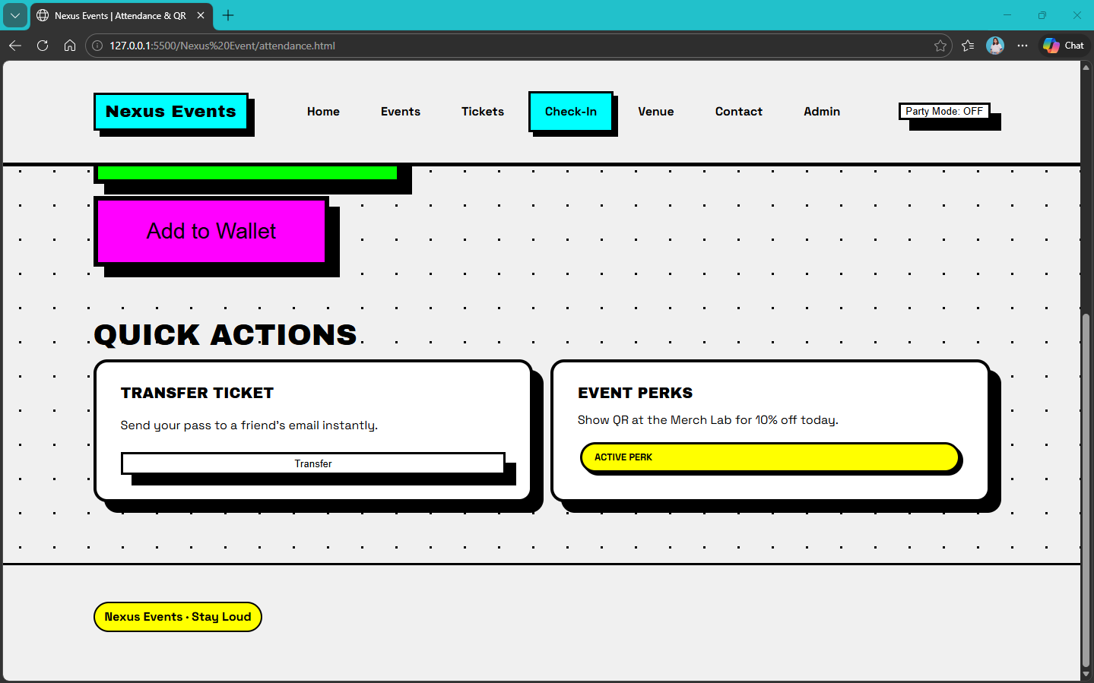

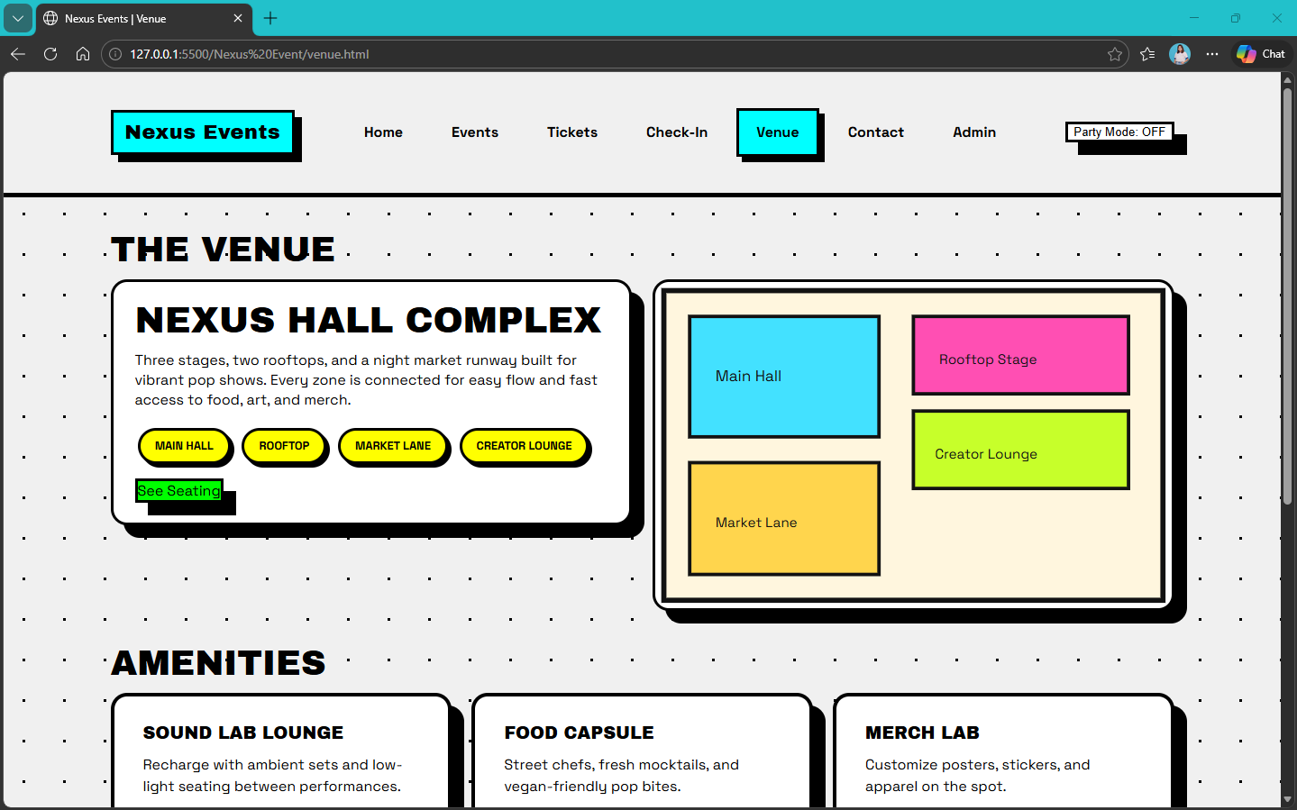
Venue Area

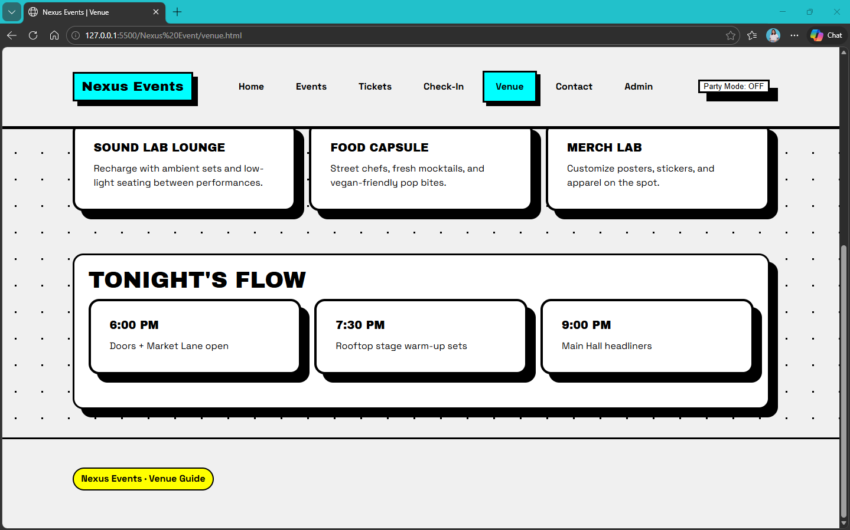
,
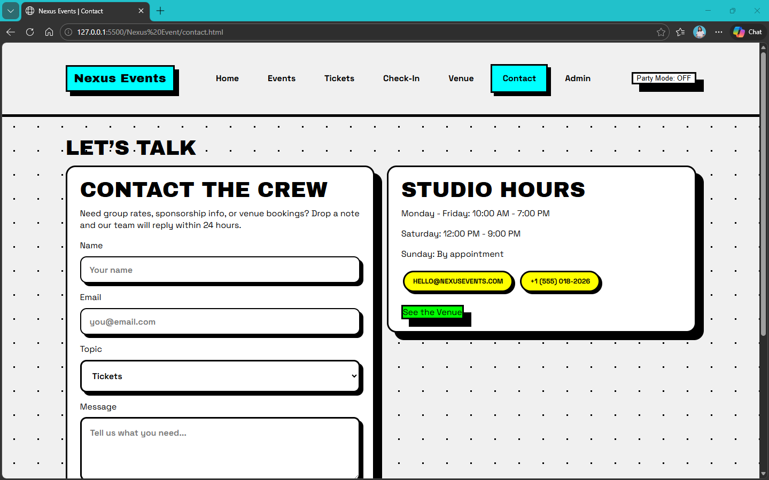
Contact Area

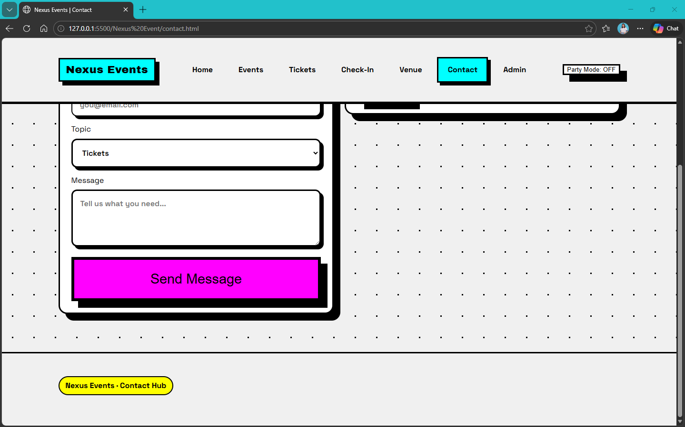
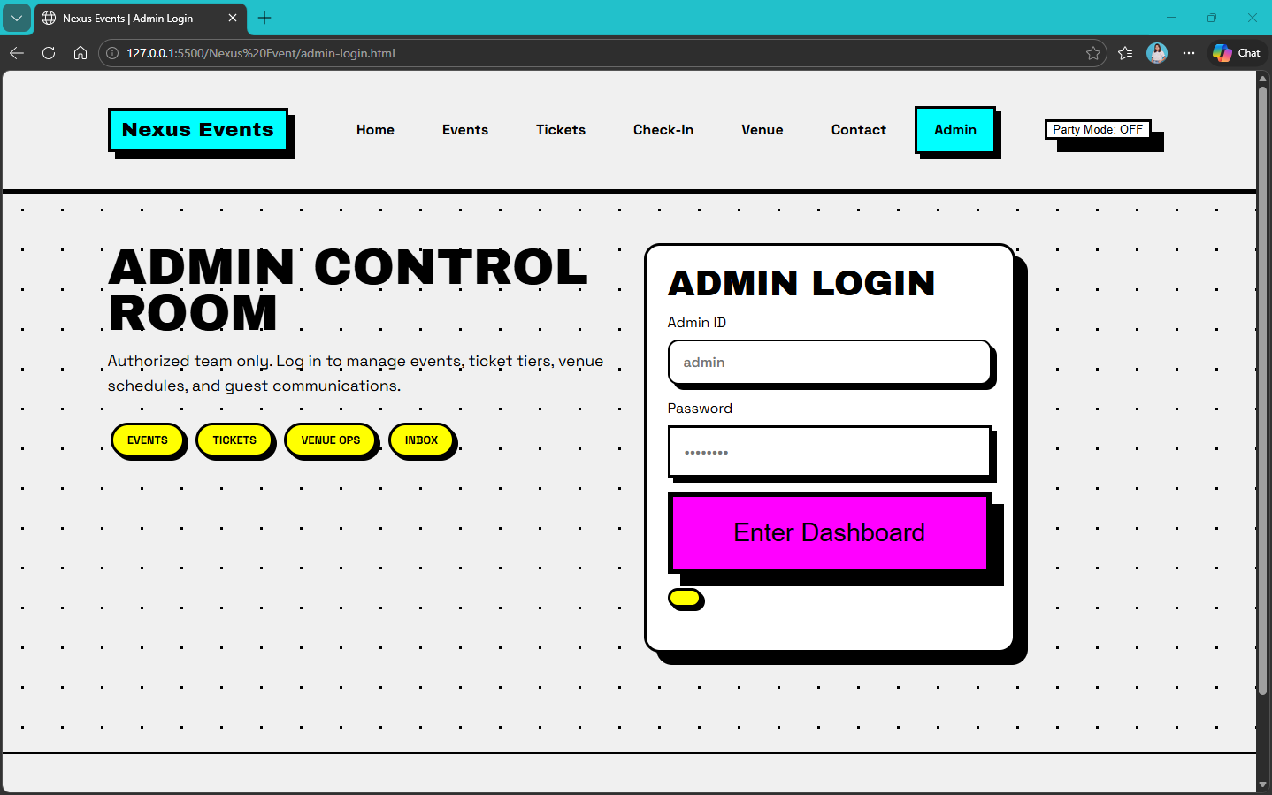
Admin Area

